Chapter 6, Solution 67.

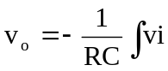dt, RC = 50 x 10³ x 0.04 x 10⁻⁶ = 2 x 10⁻³
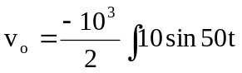dt
v_{o} = 100cos(50t) mV

